**Team Member Responsibilities:**

Christian Alcalde:

* Proximity sensor drivers
* Obstacle detection and avoidance programs
* Power

Abdullah Wardak:

* IR sensor drivers
* Path follower
* CPU

Eric Fong:

* Motor control hardware and drivers
* Accelerometer drivers
* Positional feedback mapping w/ accelerometer

**Project Name:** Autonomous Car

Our main goal is to create a car that follows a custom path made from black electrical tape. It would also have a method for avoiding obstacles and moving past them using a recursive function that allows the car to keep some distance from or “hug” an object until it finds its path again. Power will be provided to the car using 4 AA batteries in connected in series (equivalent to 6V). Battery power will be fed into a voltage regulator to supply 5V to the PCB VDD instead of the raw battery output. A switch on the car will turn the car on and off, and a button will be connected to the CPU as a reset button. The brushless DC motors we have listed on the bill of materials draw 750 mW each at load rating.

A simple project car chassis will be the base of our vehicle. It comes with two wheels and two DC motors, although we may use other motors if the included ones do not have good documentation or do not meet our required specifications.

Our CPU of choice is the ATMega328P-A, an 8-bit AVR microcontroller. It requires an operating voltage of 1.8V to 5.5V, which will be provided by our 4 AA battery pack. This particular CPU has many features that will complete our autonomous car. An I2C interface is available, allowing for connectivity to our accelerometer. The CPU has six different PWM channels, which is more than enough since we will only be utilizing two brushless DC motors connected to an H-Bridge. To program our CPU, we will be using the SparkFun Electronics Pocket AVR Programmer. It communicates with our CPU using an SPI interface. A special ribbon cable will connect the programmer to our board. This is done with a 2x3 pin header that will be included on our PCB. From here, we can plug in the programmer to a computer using a mini-B USB to USB A cable. The CPU also includes support for other communication interfaces such as UART and USART.

Path following will be implemented using three IR reflective sensor modules, the CPU, and the motor driving subsystem. The IR sensors will observe reflective values of three spots in front of the car, one in the middle and one each to either side, and send readings to the CPU as an analog signal. To read these signals, each IR sensor will be connected to an analog to digital converter, which will then connect to the CPU. If the CPU detects a change in readings from the sensor, it will execute one of two turning functions until the sensor output returns to the on-path values, then resume forward travel. A dark signal from the left sensor will encode for executing a left turn function, vice versa for right turn, and a dark signal in the middle with bright on the sides will encode for the on-path state. On the track there will be a wider section of black tape that signals for the car to stop. In order for the car to stop, all three IR sensors will turn dark for a longer time. This section will extend for the length of three seconds. Once the IR sensors turn dark for three seconds, the CPU will read the signal and decide to stop.

The motor driving subsystem will control the speed at which the motors run and the direction they move the vehicle in. Steering will be approached by running the left and right side motors at equal speeds in opposite directions to rotate the car in place, or running one motor faster than the other. To implement this, we will have the CPU send control signals to a L293DD H-bridge IC which can change the polarity of current through each motor. These same connections can be used in junction with a PWM signal to vary the average voltage supplied to the motors and produce variable speed control for the motors. The L293DD can control the polarity of two motors independently.

Obstacle detection will be implemented using two ultrasonic distance sensors to detect any objects in the way of the car. If the CPU receives a reading from either sensor indicating an obstruction is within 100 mm of the sensor, the car will activate the obstacle circumnavigation subsystem. The distance sensors connect to our CPU using 4 pins: VCC, Trig, Echo, and GND. These sensors use a custom communication interface to send its data to the CPU. The trigger pulse input pin (Trig) receives a pulse from the CPU, prompting the sensor’s transducer to send out eight 40 kHz signals. These signals will bounce on an object and back into the sensor. The echo pulse output pin (Echo) then receives this signal and performs a calculation to determine how far the object is from the sensor. The formula that the distance sensor uses for calculating the distance is the following: test distance = (high level time * velocity of sound)/2.

Obstacle circumnavigation will be triggered by obstacle detection, and will be implemented using the travel logging, obstacle detection, and motor driving subsystems on the CPU.

Implementation of the circumnavigation function. We will assume that obstacles occupy a footprint of no more than 60 cm x 60 cm. To determine whether to pass the obstacle on the right or left, we will compare the outputs of the distance sensors. If the left sensor reads a shorter distance than the right sensor, this indicates that there is more obstruction on the left, so the function will drive the car to the right, and vice versa for driving left. If both sensors give an equal output, the car will default to circumnavigating on the right of the obstacle.

After deciding the initial direction to circumnavigate, the car will drive forward while “hugging” the obstacle. If circumnavigating on the right of the obstacle and the left distance sensor reads a drop in distance, the car will drive its right motor slower to arc the car away from the obstacle until the left distance sensor reading matches the hugging-distance of ~215 mm. If circumnavigating on the right of the obstacle and the left distance sensor reads an increase in distance, the car will drive its left motor slower to arc the car closer to the obstacle until the left distance sensor reading matches the hugging distance of ~215 mm. The circumnavigation on the left of the obstacle is vice versa.

If the car detects that it’s back on its original path, it will exit the circumnavigation subsystem and switch back to the path following subsystem. With obstacles fitting in a 60 cm x 60 cm footprint, the car should not need to travel more than 250 cm to circumnavigate an obstacle at worst, so if it does travel more than that while circumnavigating, the car will be programmed to stop and display an error message on the LCD display.

The LCD Character Display that we are using has limits of 2 lines and 16 characters on each line which will be enough for our information display. The LCD has 4.7 to 5.5 V power supply. It has a white display with gray color background. The display includes four high and four low order bi-directional tri state data bus lines to display characters on the screen. Although we do not deal with very bad weather conditions, this LCD display works in -10 C to 70 C temperature.

Travel logging recording and display would be facilitated using the CPU, accelerometers, oscillator, 16x2 LCD character display, and some buttons. The accelerometers will feed data over I2C connections to the CPU on the oscillator-supplied clock cycle to log the acceleration-time info of the vehicle into data structures in memory. This data will be fed into integration algorithms to obtain velocity data, which will also be fed into another integration algorithm to obtain position data. X- and Y-axis data will be stored in individual data structures for acceleration, velocity, and position.

Integration will be accomplished using Riemann sums on the acceleration data to obtain velocity data, and on the velocity data to obtain position data.

Professor Tandon has indicated that we should seek consultation on the choosing and usage of an oscillator.

Travel metrics including total distance traveled, average speed, and average acceleration will be calculated from the acceleration-velocity-position data and be outputted on the display. displayed metrics will be scalar quantities calculated from the magnitudes of the x-y acceleration, velocity, and position logs. The display control and decoding will be handled by the CPU and onboard controller of the display which communicate over a parallel connection. The user will be able to cycle between which stat is displayed by pressing a button linked to the CPU.

Base Objectives:

* car - controls motor steering, speed, and direction
* electric-tape path following
* obstacle detection
* obstacle circumnavigation
* travel statistic logging and display
  + each accelerometer can detect acceleration in three axes
  + accelerometer logs acceleration data
  + CPU integrates acceleration data to obtain velocity data
  + CPU integrates velocity data to obtain position data. $x{}_{final}={x{{}_{0 }+v}_{0}t+\frac{1}{2} at}^{}$
  + data for each axis is logged in its own data structure instance
  + displayed scalars calculated from magnitudes of x-y data
  + Viewable from 16x2 LED character display
    - Cycle through average acceleration, average velocity, distance traveled with the push of a button

Stretch Goals:

* advanced obstacle reaction
  + get accurate obstacle readings while car is in motion
  + detect if obstacle is moving or stationary
  + back up from approaching obstacle
  + wait out through traffic
  + add another motion sensor, detect moving obstacles via triangulation/sensor differences, avoidance swerving
* log exporting via serial UART cable
  + exporting functions triggered with a button press when plugged in
  + draw a map using x-y position data from a run and export the picture

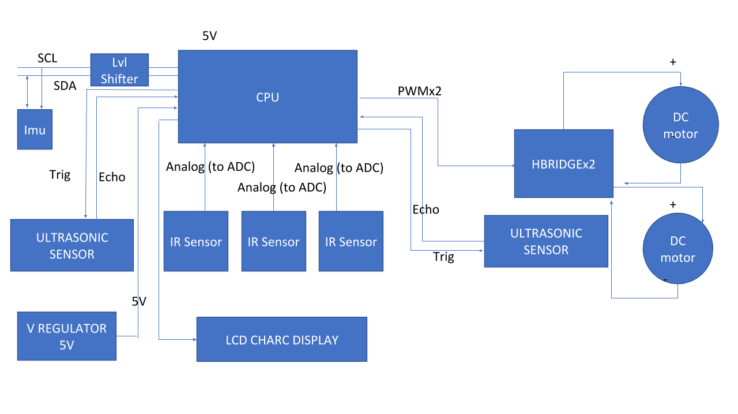

* spare CPU pins to be allocated for debugging pin headers, leds, buttons, etc. as available